Object :

Patch-clamp and yeast protoplasts isolation

Mailing list
BPMP, users of EHEV platform

- Reference/contact persons

Sabine Zimmermann

Health and safety
Use forceps to remove pipettes/capillaries from pullers.
Weigh harmful chemicals under a dedicated hood, wearing gloves

Physical risk:
- Pulling of capillaries = cuts, burns
=> Wait for cooling down or use the forceps to remove them from pullers.
- voltage-clamp = postural and visual stress because of micromanipulation under the binocular magnifier => pause every hour
Chemical risks:
Numerous chemical risks
=> weigh harmful chemicals under a dedicated hood, wearing gloves
=> prepare the solutions under a fume cupboard, and wear gloves (nitrile) during handling
Check possible chemical risks with inhibitors !

- Operating mode

Centrifugation
Yeast culture in 10 mL YPD+galactose
PLY246 yeast transformed with gene of interest
Centrifugation
Washing in Buffer B
Washing in Buffer A

Centrifugation

Buffer B + lyticase


Incubation 30°C
100 RPM 1h30

Patch-clamp
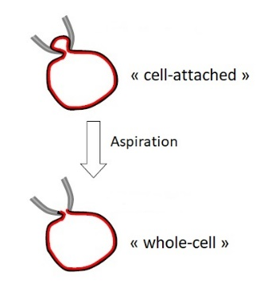
Washing in Buffer C
Protoplasts obtention
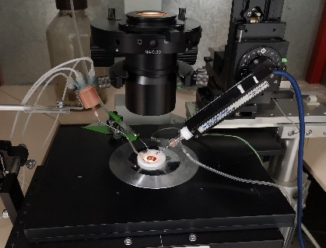
Patch-clamp setup

Suction

« whole-cell » configuration mode

Patch-clamp of yeast protoplasts after osmotic extrusion by small digestion of yeast walls.

In search of the K⁺ transport function, a triple mutant ply246 trk1Δtrk2Δtok1Δ (Bertl et al., 2003) deficient for the endogenous yeast K⁺ transporters and channel (Trk1, Trk2, TOK) is available.

Transformation of the candidate of interest can be done using the plasmide pYES2.
Yeast strain ply246 (not transformed) was used as control negative.

For complementation experiments, the medium arginine-phosphate was produced (K⁺ 5 mM, 10 mM & 50 mM). Starting from yeast cultures at absorption =1, three dilutions (factor 10) have been used.

Yeast protoplast preparation (Protocol was modified and adapted according to Bihler et al. (2002) and Roberts (2003)).

DAY 1:
1. From a previous “high-concentrated” liquid culture of yeasts in YPD+galactose, a new 10 ml fresh liquid culture with YPD+galactose was prepared (Attention, here vecteur pYES inductible par galactose, promoter pGAL1). Depending on the “yeasts concentration” of the previous culture, around 10-20 µl of this culture have been added into 10 ml of YPD+galactose.
2. Let grow overnight at 30°C – 160 RPM (stirring), eg from 18h/19h to 11h the next morning.

2. DAY 2:
1. Centrifuge the 10 ml liquid yeast culture at 500 g/RCF (around 1576 rpm, depending on the rotor) for 5 min.
2. Discard carefully the supernatant (with pipette) and rinse and resuspend completely the pellet with 10 ml of Buffer A.

Buffer A

KH₂PO₄ 50 mM
β-mercaptoéthanol 40 mM
pH 7

3. Centrifuge at 500 g for 5 min.
4. Discard carefully the supernatant and rinse/resuspend completely the pellet with 2 ml of Buffer B.

Buffer B

KH₂PO₄ 50 mM
β-mercaptoéthanol 40 mM
Sorbitol 1,2 M
pH 7

5. Centrifuge at 500 g for 5 min.
6. Discard carefully the supernatant and resuspend completely the pellet with 2 ml Buffer B supplemented with the lyticase enzyme (L4025-25KU – Sigma-Aldrich, final concentration 1 mg ml⁻¹). To have the right volume of Buffer B and lyticase, calculate it with the final concentration of the lyticase enzyme at 1 mg/mL. For example, with an initial concentration of 10 mg/mL of lyticase, put 1,8 mL of Buffer B and 200 µL of lyticase enzyme to have 1 mg/mL.
Advice: resuspend first the pellet with the Buffer B and then, add the lyticase enzyme.

7. Incubate at 30°C – 100 RPM – 1h30 for the enzymatic digestion of the yeast cell wall.
8. Centrifuge at 500 g for 10 min.
9. Discard carefully the supernatant and rinse and resuspend completely the pellet with 5 ml of Buffer C (cf. Roberts).

Buffer C

Sorbitol 1 M
CaCl₂ 1 mM
HEPES 10 mM
pH 7

10. Centrifuge at 500 g for 10 min. Discard carefully the supernatant and resuspend completely in 1 ml of Buffer C (Cf. Roberts). Put the protoplasts on the ice. They are ready-to-use. If you prepare the protoplasts in the late morning, they will be usable until the end of the afternoon/evening maximum (8-10h).

Yeast patch-clamp (set-up, protocol, analyses)

To measure membrane currents across the yeast protoplast membrane, the electrophysiology method “patch-clamp” has been used according to (Neher & Sakmann, 1976; Bihler et al., 2002; Roberts, 2003). Yeast protoplast (maintained on ice) are added to the “patch chamber” filled with the Sealing solution.

Sealing solution

KCl 10 mM
CaCl₂ 10 mM
MgCl₂ 5 mM
HEPES 5 mM
Tris-amino 10 mM
pH 7 and adjusted to roughly 600 mosmol by adding sorbitol, and filtered.

The "patch-clamp" setup with the microscope is installed in a Faraday cage to eliminate electrical noise and on an anti-vibration table. The patch-pipette is installed at the headstage on a micromanipulator. The reference electrode is in the bath.

Patch pipettes are made from borosilicate capillaries (GC150F-7.5; Phymep, France) by a pipette puller (DMZ-Universal Puller, Zeitz-Instruments GmbH, Allemagne) and heat polished. The diameter has to be very fine (due to the little size of yeast protoplasts), less than 1 μm (around 5 MΩ in free bath solution). They are filled with pipette solution (replacing the cytosolic solution) maintained on ice.

Pipette solution

KCl 10 mM
Potassium gluconate 100 mM
MgCl₂ 5 mM
Mg²⁺ATP 4 mM
HEPES 10 mM
EGTA 4 mM
KOH 20 mM
pH 7 and adjusted to 600 mosmol with sorbitol, and filtered.

When the point of the pipette is touching the surface of the protoplast, a slight depression is applied (suction by mouth) by the tube connected to the patch-pipette in order to seal tightly the membrane. Stay patient! Slowly increasing the resistance….

If the electrical resistance reach several hundred MΩ up to GΩ (=GigaOhm) the needed GigaSeal is obtained in the configuration “cell-attached”. Using another suck puls (take care!!), the membrane patch is disrupted, and in the best case the resistance is still fine, so that the configuration “whole-cell” is obtained and currents mediated by channels/transporters of the whole cellular membrane can be measured.

Given the little size, these currents are still rather small. In this configuration, the pipette solution determines now the cytosolic membrane side, the exchange is rapidly obtained. The external solution (=bath solution) can be exchanged to test different concentrations or inhibitors etc (used bath solution here).

Bath solution

CaCl₂ 1 mM
HEPES 10 mM
Tris-Amino 10 mM
KCl 10 mM or 100 mM
pH 7 and adjusted to 600 mosmol with sorbitol and filtered.

Then the membrane potential is clamped and voltage pulse programs are applied to measure the current responses (interface Digidata 1322A Axon Instrument, amplifier Axopatch 200B, Axon Intrument, software for data acquiring and analyses (Clampex & Clampfit 10, Axon Instrument, Molecular Devices).

Current-voltage (IV) graphs are constructed by measuring the currents at the end of the voltage pulses (steady-state), tail currents are analyzed to determine the selectivity (reversal potential Erev) by measuring currents at the beginning of a voltage jump after activating the currents.

